|  |  |
| --- | --- |
| Due Date: | **15 September 2017** |
| Total Marks: | **100** |
| Weighting: | **20% of final mark** |

|  |
| --- |
| Assessment Guidelines |
| * You are required to submit an electronic copy of this Assignment. * Your documentation file should be saved as ***yourStudentID_IT7320_Assignment2.docx*** * If you have more than one file to submit, please make sure that you place them in a folder and then zip/compress them before submitting. * Submit your work on or before the due date.   The submission box will be set to close at a specified time and will no longer be accessible after that. |
| Late Work & Extension |
| * Handing in the work after the due date without extension is considered **late**. Students will be advised of any penalties to be imposed for late submission. * The lecturer reserves the right not to mark work that is handed in late. * Under exceptional circumstances (e.g. bereavement, illness, accident) students may be granted an extension of the due date of Assignment 2. * Extensions are **not** granted automatically. A request for extension must be made at least 24 hours before the deadline of Assignment 2. If a student applies for an extension, a relevant evidence (e.g. medical certificate) must be presented. |
| Pass Requirements |
| * Students must attempt all three Assignments and Exam. * Students must obtain at least 40% in the examination and a final mark average of 50%. |

**Summary of Tasks for Assignment 2**

For this assignment, you are required to show your competency in:

1. Designing software solution using Agile approach in SDLC.
2. Use of testing framework
3. JUnit testing and assertions
4. Exception Handling in JUnit
5. Use of project management tool and comprehension tools such as Maven and GitHub in creating simple project that includes JUnit testing

**Tasks [100 marks]**

Following are the tasks that each student must accomplish for Assignment 2.

**PART I – Using Agile Model**

The Hutt City Council is in-charge of managing all parking services in Lower Hutt. Their services include monitoring parking zones by time limits, Pay & Display machines and many more. The parking costs depend on the zone you park in. For instance, the parking charges for Shoppers’ zone HC2 (Green) are as follows:

* $1.50 per hour
* Two-hour maximum parking duration
* Monday to Friday 9:00 – 5pm
* Saturday P120 (no charge)
* Sunday and public holidays unrestricted

Your task is to find out the common issues or concerns raised by car owners when parking in the city. Identify some hassles in the given scenario and restrictions and discuss the possible solution with your group.

Based on your analysis, use the **agile** modelling approach that involves:

1. **Planning**
2. **Requirement Analysis**
3. Design
4. Building/Coding
   1. You can use any platform (e.g., Java, Android).
   2. Use Maven project management or build tool (Gradle for Android).
   3. Use Git and GitHub for your local and remote repositories.
5. Unit Testing
   1. Use JUnit testing
   2. Implement Exception handling in JUnit
6. Acceptance Testing

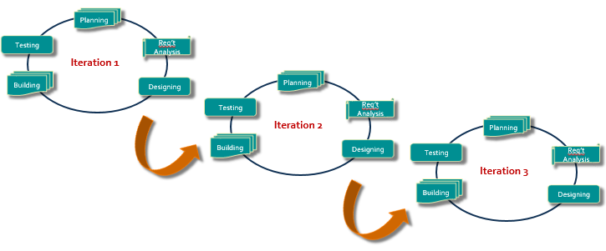

Figure 1. Agile Model

**PART II – Research**

1. Based on your experience in using JUnit, research and answer the following questions:
   1. ***How will you test a method in a class that does not return anything?*** – explain and provide a relevant example to demonstrate your idea.
   2. ***Is it possible to write a test that will pass when the expected exception is thrown?*** – explain your answer and give an example.
   3. ***What factors are you going to consider in designing an effective unit test?***
2. Refer to the link below to see the Assert class documentation.

<http://junit.org/junit4/javadoc/latest/org/junit/Assert.html>

* 1. Select at least three assertion methods and implement them in a test case. You can reuse your code or create a new class where you think these assertion methods would be relevant. The objective is for you to be able to demonstrate the use of different assertion methods in your JUnit test case.
  2. Explain how you implemented the three assertion methods.